Milestone 1 Submission 1 by Group 1

Proposed Level of Achievement: Gemini

# Panopto Plus

A Chrome extension to improve the user experience of webcasting

**Motivation**

Webcasts, or web lectures, are recordings of lectures held by professors. These webcasts allow students to review and revise lectures and are helpful to students as webcasts can be viewed at any time, any location and even at a faster playback speed to facilitate learning.

For webcasts by NUS, these webcasts are hosted on a website named Panopto. Although the website and webcasts are sufficient for learning, improvements can be made to enhance the user experience of users.

Firstly, the user interface of the Panopto website can be improved. In its current state, the playback of webcasts can only be increased up to two times the speed. The user interface is also filled by unnecessary web elements such as the over-sized carousel/slider for webcast timestamps, when the focus should be on the webcast itself. These can be modified to allow users to increase the playback speed beyond the current x2 speed and remove unnecessary clutter and improve the user experience.

Secondly, machine transcribed subtitles and transcripts can be introduced. With their introduction, even if they may not be entirely accurate, students will be able to use them to skim through certain sections of the webcasts.

Finally, there are sections in the webcast where the professor is writing, thinking or waiting. Since the professor isn’t teaching during these moments of silence, they can be removed without hindering the students’ learning. Depending on the lecture, the removal of these silences can reduce the duration of a web lecture by half, or even down to a quarter of its original duration.

This is not an urgent problem to be solved, but with the development of this project, users will be able to both hear and read what the professor is saying, and enjoy shorter webcasts without compromising their learning.

**Aim**

We hope to improve the user experience of webcasting on the browser Google Chrome through a Chrome extension.

**User Stories**

1. As a student, I want to reduce the time I spend on webcasts while maintaining the same level of comprehension and learning.
2. As a student, I want to have the option of fast-forwarding my lectures at a playback speed higher than two times the original speed.
3. As a student, I want to be able to skim through what the professor is saying during the webcast. A transcript of what the professor is saying would be helpful.
4. As a student, I find that some professors spend a lot of time pausing to write or to think during their lectures. Although this is understandable, I would prefer if these moments of silence were removed from my webcasts.

**Scope of Project**

The Chrome Extension will serve 3 main purposes:

* The Chrome extension will inject HTML, CSS and JS into the page to improve user-friendliness. There will be a side-bar for users to configure the extension settings.
  + Wider range of video playback speeds, restructuring of page to allow for more space for the video webcast
  + Persistent settings across webcasts e.g. always play all webcasts at 2.0x speed.
* Machine Text Transcription (Machine-generated subtitles for webcasts) will by generated by Panopto. This Chrome extension will leverage on that and process the transcript into subtitles and a user interactable transcript.
  + Users can click sections of the transcript to seek to that video timeframe
* The Chrome extension will also process files of the webcast for voice detection. Sections in the webcast where there is no speech will be automatically skipped.

These features are toggleable (except user-interface modifications to the Panopto webpage).

**Total list of key features, tasks and details:**

|  |  |  |
| --- | --- | --- |
| **Category** | **Details** | **Deadline** |
| UI | Sidebar with tabs | Mid June |
| UI | Smaller carousel* | Mid June |
| UI | Removal of Panopto header if loaded on LumiNUS | Mid June |
| UI | Replace playback Speed buttons with slider | Mid June |
| Subtitles | Retrieval and caching of transcript from Panopto via REST API | Mid June |
| Subtitles | Conversion of transcript from Panopto to suit app’s purposes | Mid June |
| Subtitles | Display of subtitles on video(s) | Mid June |
| Subtitles | Properly synced subtitles on both videos (two video webcasts) | Mid June |
| Silence Removal | Basic implementation (demuxing, decoding & processing using AudioWorklet) | Mid June |
| Silence Removal | Skipping mechanism based on silent sections detected | Mid June |
| Misc | Error logging module | Mid July |
| UI | Consistent UI & UX for single video and double video webcasts | Mid July |
| UX | Persistent settings across webcasts under the same module and settings tab to reflect that | Mid July |
| UI | Transcript sidebar (hideable) even on fullscreen | Mid July |
| UI | Other miscellaneous improvements** | Mid July |
| Transcripts | Transcripts on the sidebar | Mid July |
| Transcripts | Highlighted line in transcript in sync with video | Mid July |
| Transcripts | Clicking of line in transcript will seek to section of the video | Mid July |
| Silence Removal | Extension of basic implementation: caching of results, async, multiple webworklets and audioworklets | Mid July |
| Misc | Generation of JSDocs | Mid July |
| Misc | Optimizations, use of webpack to reduce size of chrome extension and manifest links | Mid July |

*Carousel refers to the carousel web element below the main webcast on the Panopto page, which allows users to see a “snapshot” of the webcast at that time.

**May include mobile responsiveness, if one is able to deploy chrome extensions on the mobile phone. This may not be possible on the Chrome browser on Android, but it *might* be possible on the browser Yandex. May also include modifications to the video player bar.

**List of possible enhancements beyond key features**

List of features thought to be potentially useful / interesting, but Keep In View (KIV)

|  |  |
| --- | --- |
| **Category** | **Details** |
| Downloads | Download feature with subtitles embedded and silent sections trimmed |
| UI | Hide-able sidebar |

**How are we different from similar platforms?**

There are no existing solutions to this problem, but there is another group in Orbital 2019 doing a very similar project. Unfortunately, they have declined to work together to produce a combined product. Hence, for the sake of comparison, a few justifications on our project scope decisions must be explained:

Their product will have the following features:

* 1. Adjust play speed
  2. Subtitles
  3. Saving of webcasts
  4. Adding webcasts to playlists
  5. Bookmarks list / un-finished list

In comparison, our project scope currently does not include features c, d and e and only has silence trimming as an additional feature over features a and b. At first glance, it appears as if their project is everything that this project is but with more features. However, this is by design.

We believe that feature c is worth pursuing only as an extension of the project (i.e. Milestone 3) as there are various complexities in implementing this feature. Panopto allows this feature conditionally (downloads can be forbidden for some webcasts), but the complexity comes in embedding the subtitles and trimming the silences from the webcast. As such, we would rather focus on the core features and treat it as an extension of the project once the core features are finished.

We feel that for our project, feature d is unnecessary as LumiNUS already groups all webcasts under a module in a single page.

We also believe that feature e is unnecessary for our project because Panopto already has a bookmark feature.

**Program Flow**

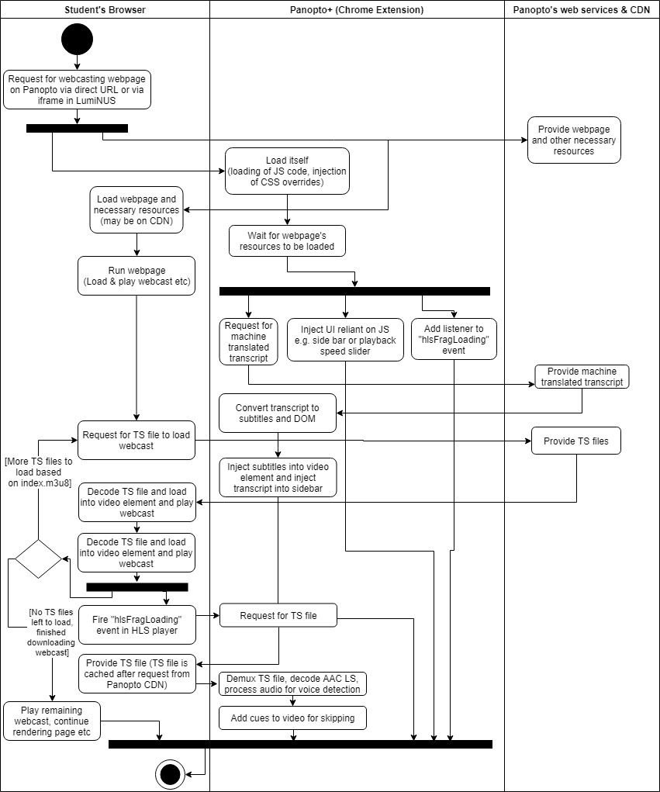

The Program Flow for our project is very simple from the perspective of the user. The user will only need to install the Chrome extension and all upgrades will be made automatically applied. He may toggle Machine Text Transcription and Auto skipping of silent sections under settings.

**Technologies Involved**

The Chrome Extension will be developed using web technologies i.e. HTML5/CSS & JS, but most of the code will be in JS. Git will be used for version control. Since this is a Chrome extension and students will be our main users, we will target the latest version of Chrome (version 74). However, older versions of Chrome up until version 55 (released in December 2016) should also be able to support this extension but we offer no guarantees.